STUDENT OF THE MONTH

Greenville Consolidated School would like to congratulate the following elementary students for receiving student of the month! Greenville school recognizes two students each month in grades K through five. In order to be selected for student of the month, one must be very responsible, motivated, and a passionate student. These students are selected by their classroom teachers and are seen coming to school every day with a smile, an excitement for learning, and a dedication for going above and beyond. These students also take the time to make sure their daily work is accurate and of the utmost quality, set positive examples for their peers in school and within the community. Congratulations to the students of the month!

September 2019
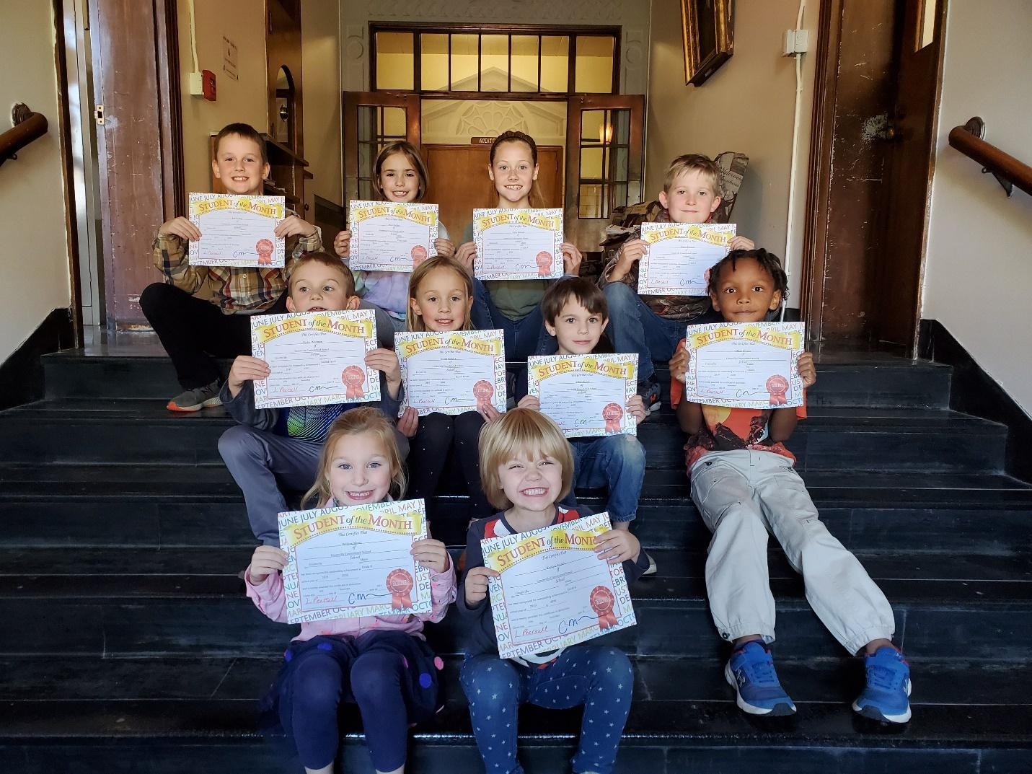
Front row starting from left to right:
Willow Menz (K), Kaitlyn Nichols (K), Ryder Whitman (2), Astrid Seeback (2), Alden Brown (1), Okan Oryem (1), Les Young (3), Maya Kelley (3), Katie Hanson (4), and Parker Poland (4).

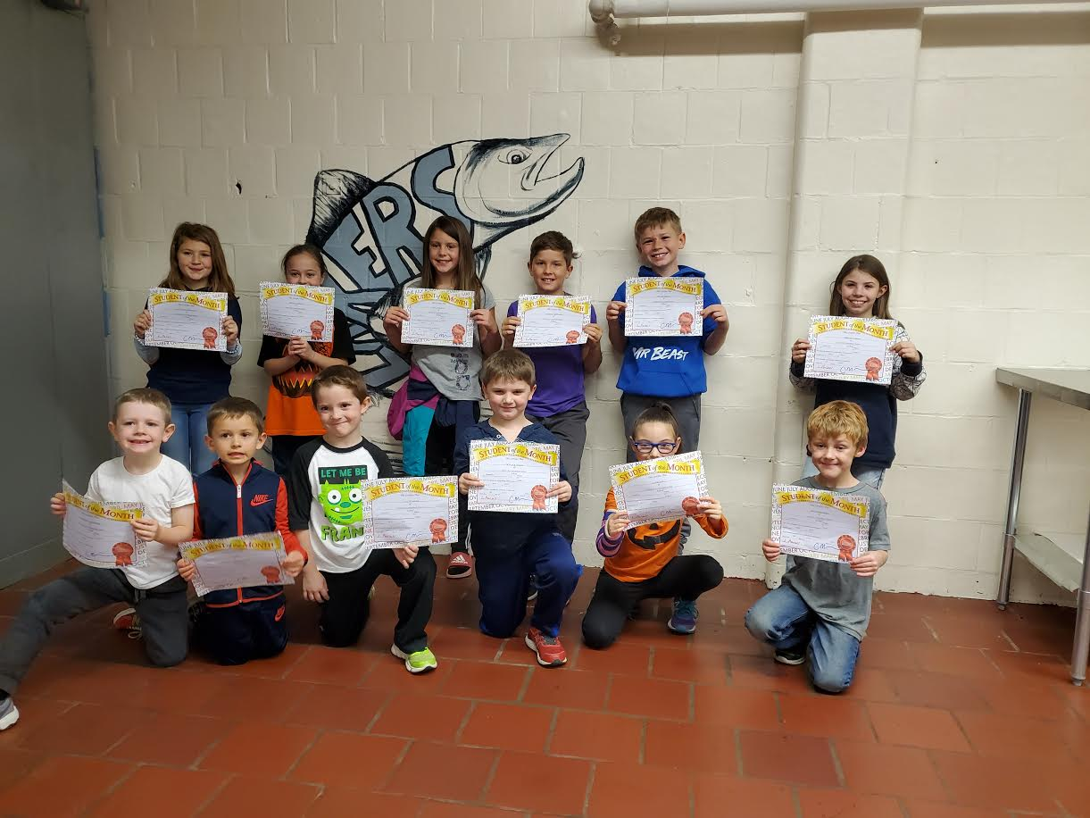
October 2019
Front row starting from left to right:
Findley Heffner (K), Eli Wopat (K), Caleb Mann (1), Wylder White (1), Eavie Ball (2), Kevin Nichols (2)
Back row starting from Left to right:
Peyton Woodbury (3), Riley Cassidy (3), Nola Mason (4), Landon Theriault (5), Ryler Mello (4), and Makenna Cashman (5)

November 2019
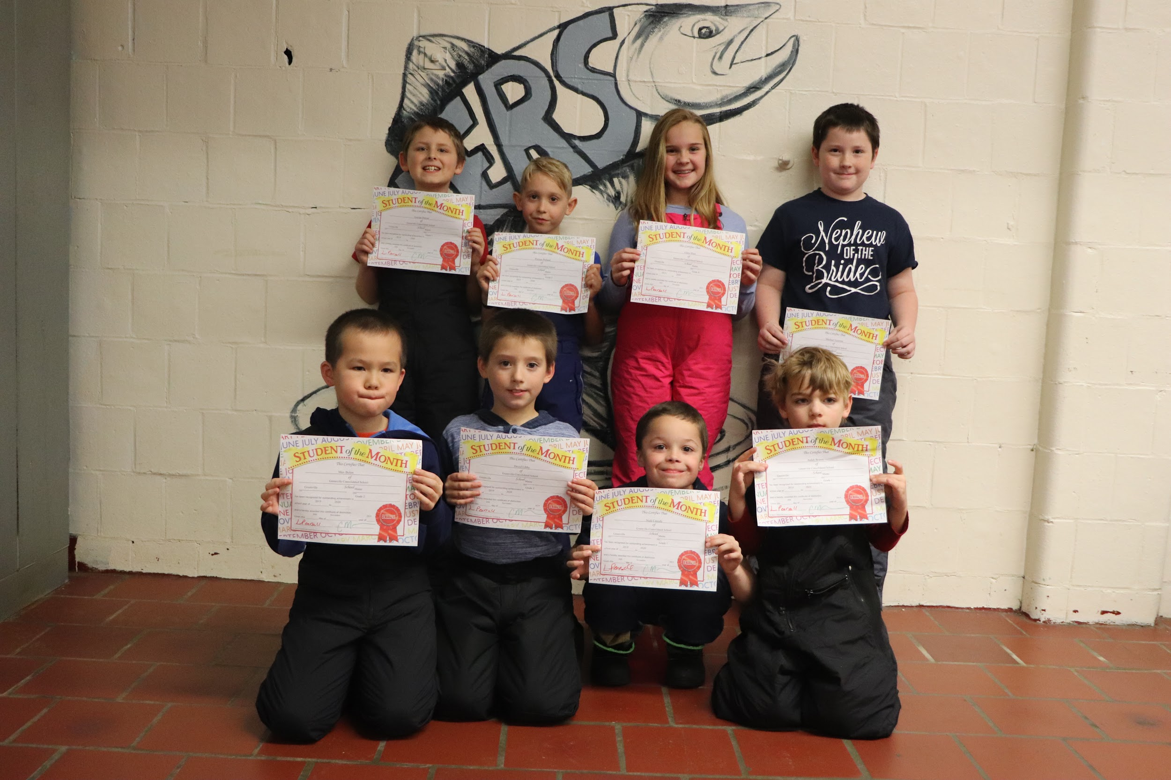
Front- left to right: Max Bolen (2), David Libby (2), Nick Cassidy (1) and Judah Brawn (1).
Back- Left to Right: Lucian Durose (3), Pierson Polland (3), Clara Hunt (4), and Michel Nystrom (4).
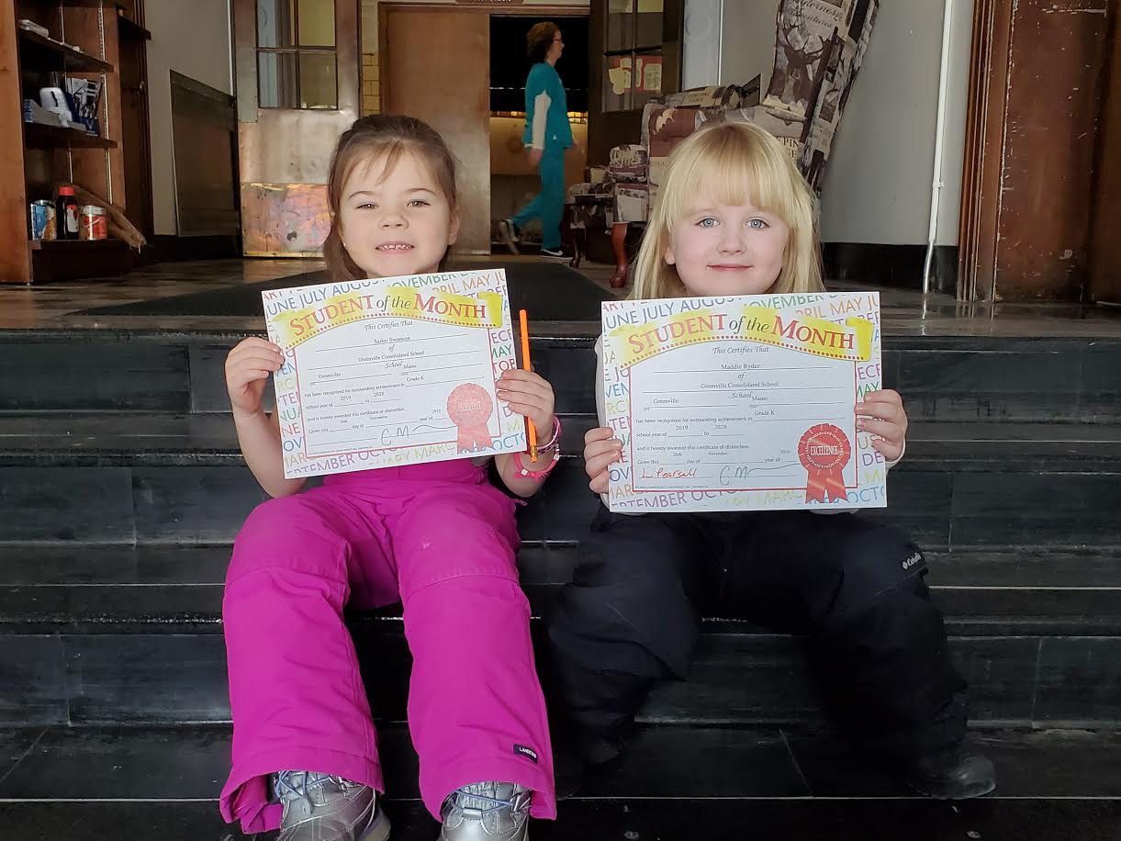

Left: Sailor Swanson (k) and Maddie Ryder (k)
December 2019
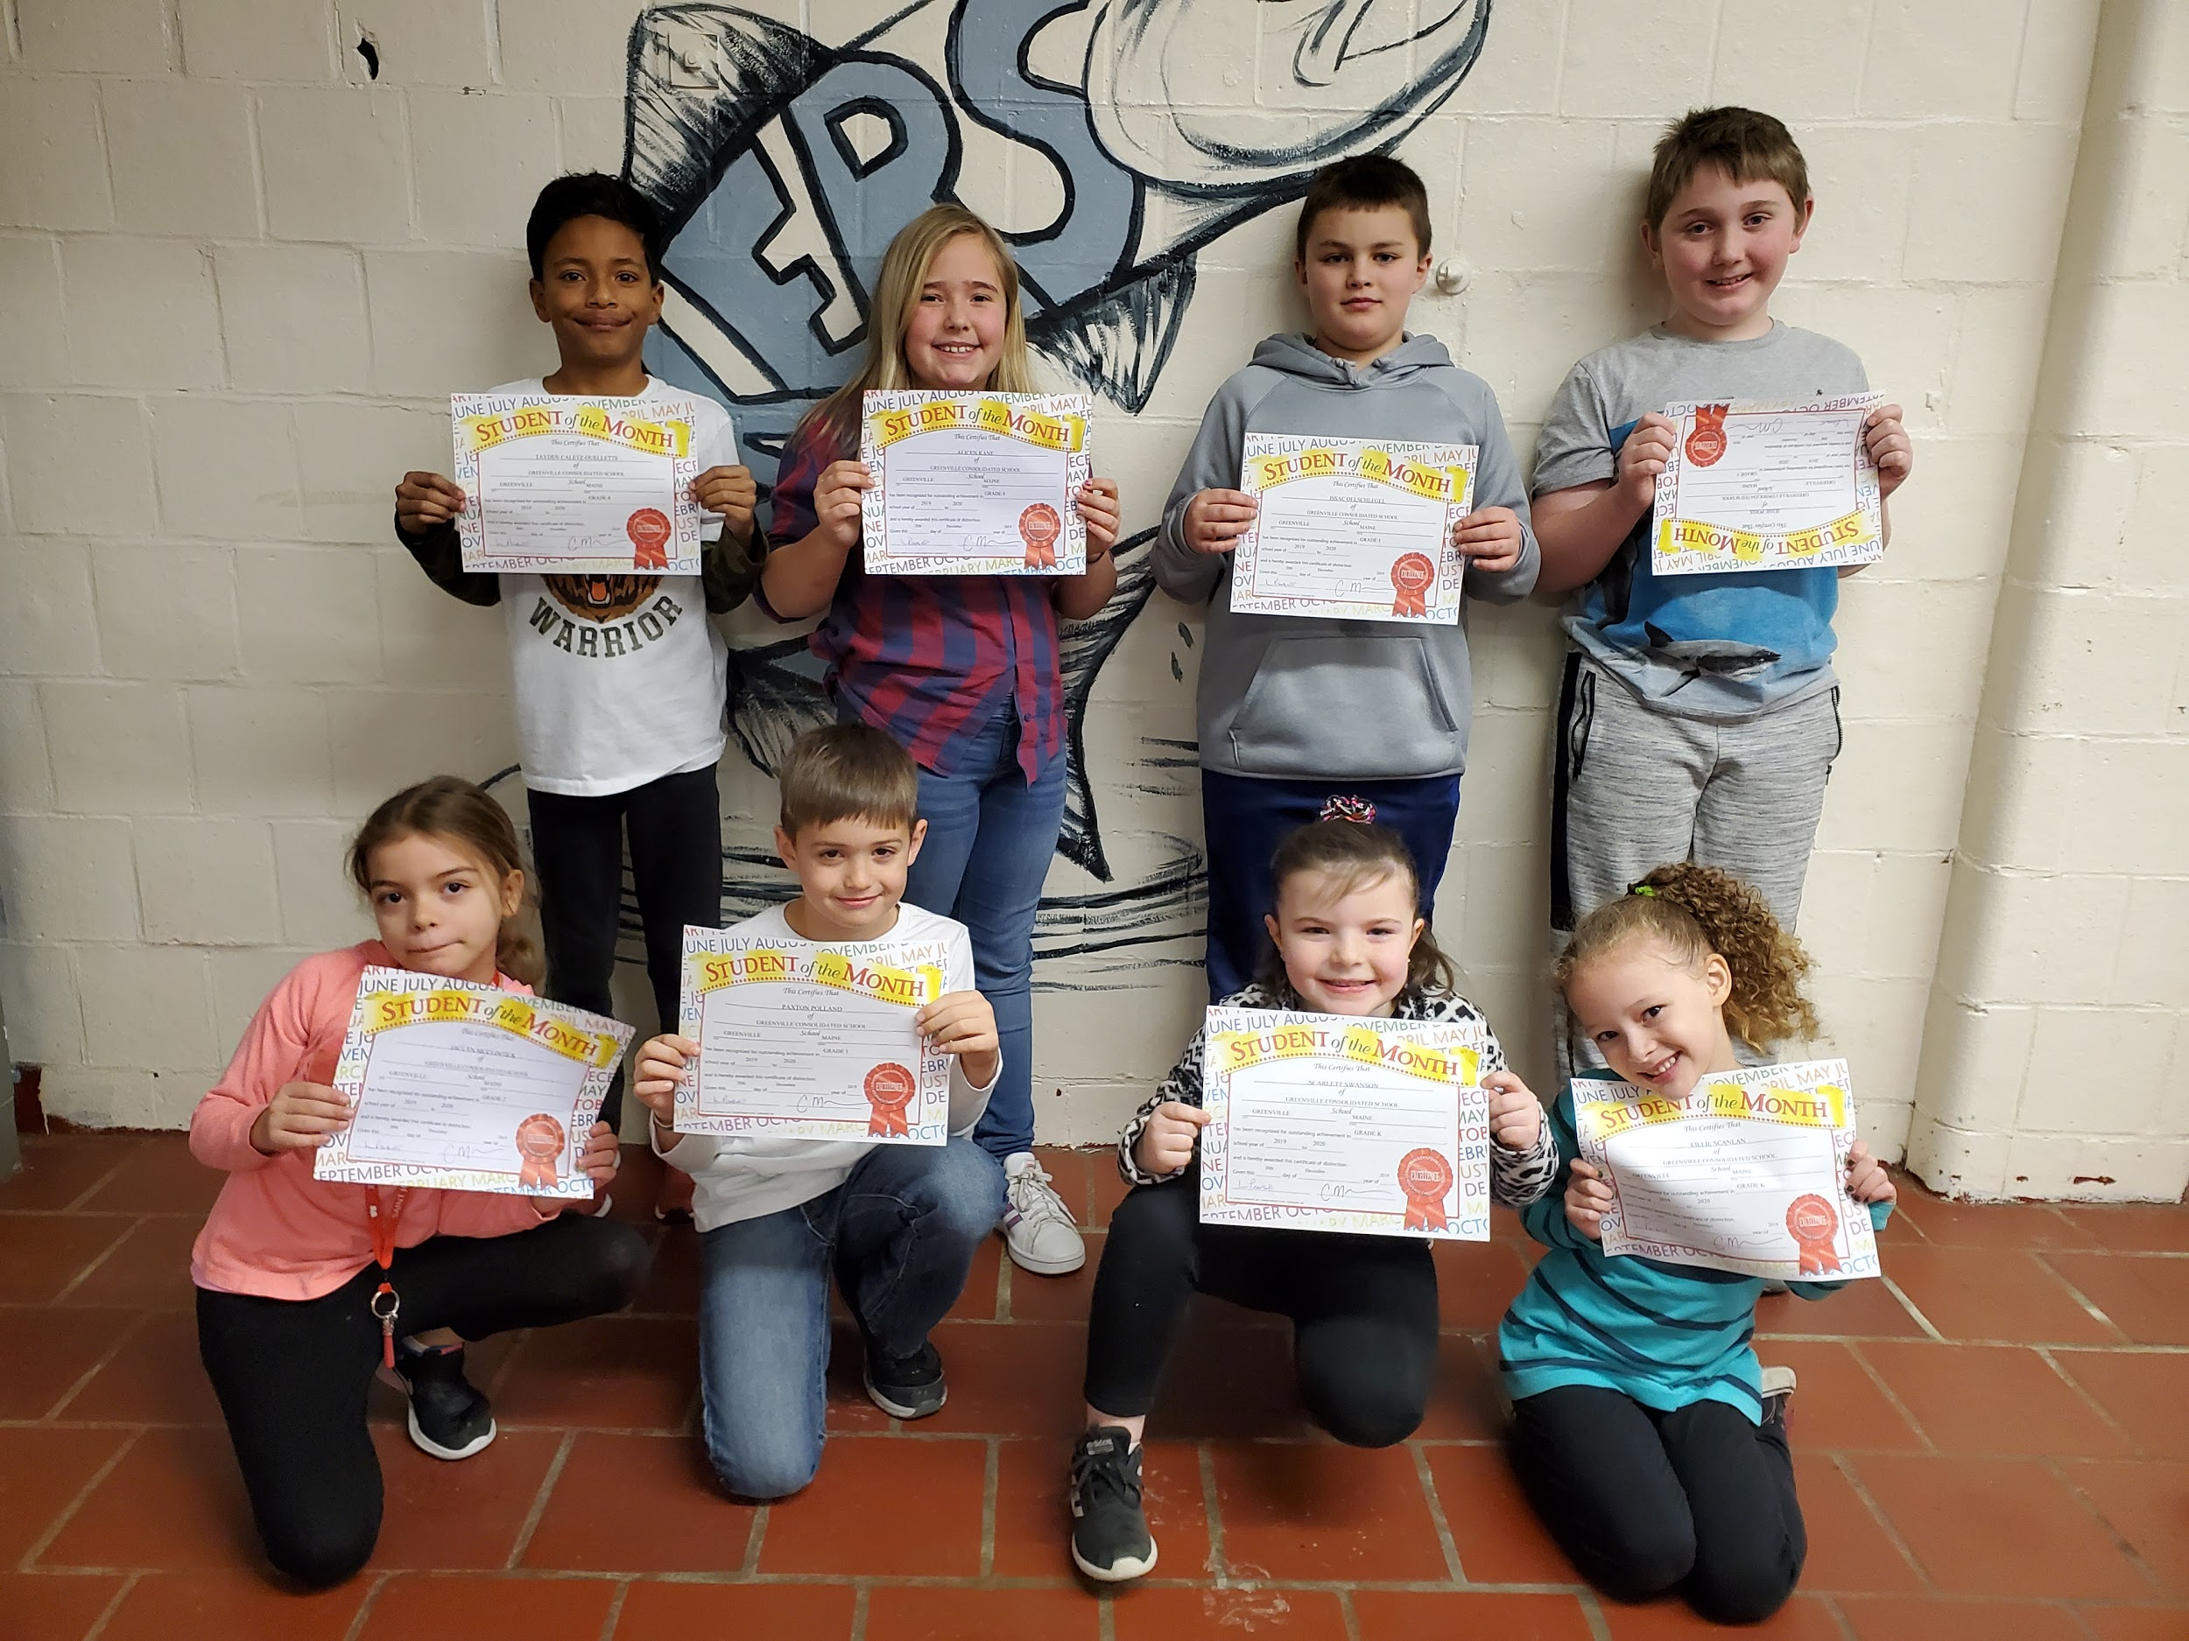

Front- Left to Right: Jaclyn McClintick (2), Paxton Polland (1), Scarlett Swanson (K), Lillie Scanlan (K).
Back- Left to Right: Taydin Caletz-Ouellette (4), Alicen Kane (4), Issac Oelschlegel (3), Jesse Poiss (3)
Absent from photo- Jackson Aucoin (1)

